**File 1**

**Scenario 3: Dead Prime Minister High School**

**Introduction:**

This database is about the basic organisation that will support the operation and working of the school.

**Entities in the database:**

* Student data: This entity is used to keep track of the personal information about the students.
* Legal guardian data: This entity keeps the information about the guardian of each student.
* Enrollments: This entity keeps track of enrolling information of each student.
* Disciplinary actions: This entity keeps track of disciplinary actions taken in the school.
* Standardized testing results: This entity holds the data of each student’s test information and results.
* Extracurricular activities: This entity keeps the track of all the extra activities each student is participating in.
* Post high school plans: This entity keeps the track of each student’s future plans after high school.

**Business rules:**

* A student must have at least one legal guardian.
* Legal guardian must have one or more students.
* A student must be enrolled in at least one course.
* Each course must have one or more students.
* A student can have zero, one or more disciplinary actions.
* A disciplinary action must involve at least one student
* A student can have zero, one or more extracurricular activity
* An extracurricular activity must involve one or more students.
* A student can have zero, one or more post high school plans.

**Unknowns:**

* Can a student have an extracurricular activity only once?
* Can a student not be involved in any disciplinary action?
* Can a student be without any post high school plans?

**Assumptions:**

* A student can be in many extracurricular activities in different years.
* The student will not be included in the disciplinary actions table.
* A student may not have applied in any post secondary institutions.

**File 2**

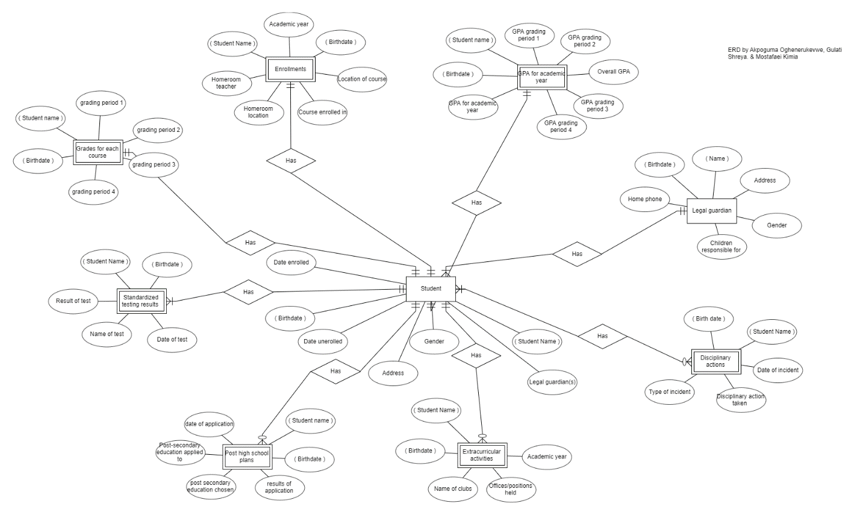

**File 3**

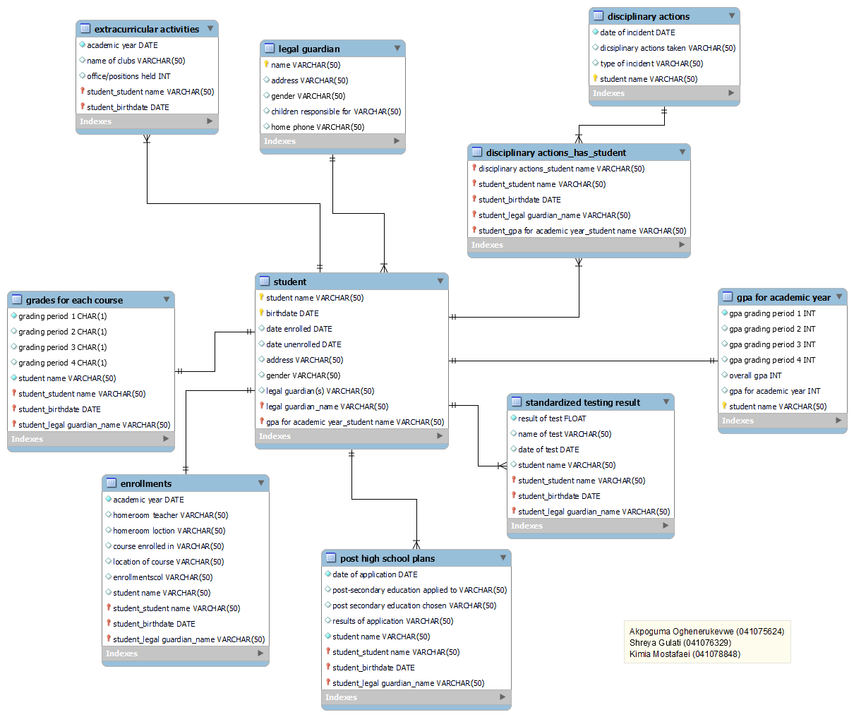

**File 4**

-- MySQL Script generated by MySQL Workbench

-- Sun Oct 23 22:37:52 2022

-- Model: New Model Version: 1.0

-- MySQL Workbench Forward Engineering

SET @OLD_UNIQUE_CHECKS=@@UNIQUE_CHECKS, UNIQUE_CHECKS=0;

SET @OLD_FOREIGN_KEY_CHECKS=@@FOREIGN_KEY_CHECKS, FOREIGN_KEY_CHECKS=0;

SET @OLD_SQL_MODE=@@SQL_MODE, SQL_MODE='ONLY_FULL_GROUP_BY,STRICT_TRANS_TABLES,NO_ZERO_IN_DATE,NO_ZERO_DATE,ERROR_FOR_DIVISION_BY_ZERO,NO_ENGINE_SUBSTITUTION';

-- -----------------------------------------------------

-- Schema mydb

-- -----------------------------------------------------

-- -----------------------------------------------------

-- Schema mydb

-- -----------------------------------------------------

CREATE SCHEMA IF NOT EXISTS `mydb` DEFAULT CHARACTER SET utf8 ;

USE `mydb` ;

-- -----------------------------------------------------

-- Table `mydb`.`legal guardian`

-- -----------------------------------------------------

CREATE TABLE IF NOT EXISTS `mydb`.`legal guardian` (

`name` VARCHAR(50) NOT NULL,

`address` VARCHAR(50) NULL,

`gender` VARCHAR(50) NULL,

`children responsible for` VARCHAR(50) NULL,

`home phone` VARCHAR(50) NULL,

PRIMARY KEY (`name`))

ENGINE = InnoDB;

-- -----------------------------------------------------

-- Table `mydb`.`gpa for academic year`

-- -----------------------------------------------------

CREATE TABLE IF NOT EXISTS `mydb`.`gpa for academic year` (

`gpa grading period 1` INT NOT NULL,

`gpa grading period 2` INT NULL,

`gpa grading period 3` INT NULL,

`gpa grading period 4` INT NULL,

`overall gpa` INT NULL,

`gpa for academic year` INT NULL,

`student name` VARCHAR(50) NOT NULL,

PRIMARY KEY (`student name`))

ENGINE = InnoDB;

-- -----------------------------------------------------

-- Table `mydb`.`student`

-- -----------------------------------------------------

CREATE TABLE IF NOT EXISTS `mydb`.`student` (

`student name` VARCHAR(50) NOT NULL,

`birthdate` DATE NOT NULL,

`date enrolled` DATE NULL,

`date unenrolled` DATE NULL,

`address` VARCHAR(50) NULL,

`gender` VARCHAR(50) NULL,

`legal guardian(s)` VARCHAR(50) NULL,

`legal guardian_name` VARCHAR(50) NOT NULL,

`gpa for academic year_student name` VARCHAR(50) NOT NULL,

PRIMARY KEY (`student name`, `birthdate`, `legal guardian_name`, `gpa for academic year_student name`),

INDEX `fk_student_legal guardian1_idx` (`legal guardian_name` ASC) VISIBLE,

INDEX `fk_student_gpa for academic year1_idx` (`gpa for academic year_student name` ASC) VISIBLE,

CONSTRAINT `fk_student_legal guardian1`

FOREIGN KEY (`legal guardian_name`)

REFERENCES `mydb`.`legal guardian` (`name`)

ON DELETE NO ACTION

ON UPDATE NO ACTION,

CONSTRAINT `fk_student_gpa for academic year1`

FOREIGN KEY (`gpa for academic year_student name`)

REFERENCES `mydb`.`gpa for academic year` (`student name`)

ON DELETE NO ACTION

ON UPDATE NO ACTION)

ENGINE = InnoDB;

-- -----------------------------------------------------

-- Table `mydb`.`disciplinary actions`

-- -----------------------------------------------------

CREATE TABLE IF NOT EXISTS `mydb`.`disciplinary actions` (

`date of incident` DATE NOT NULL,

`dicsiplinary actions taken` VARCHAR(50) NULL,

`type of incident` VARCHAR(50) NULL,

`student name` VARCHAR(50) NOT NULL,

PRIMARY KEY (`student name`))

ENGINE = InnoDB;

-- -----------------------------------------------------

-- Table `mydb`.`extracurricular activities`

-- -----------------------------------------------------

CREATE TABLE IF NOT EXISTS `mydb`.`extracurricular activities` (

`academic year` DATE NOT NULL,

`name of clubs` VARCHAR(50) NULL,

`office/positions held` INT NULL,

`student_student name` VARCHAR(50) NOT NULL,

`student_birthdate` DATE NOT NULL,

PRIMARY KEY (`student_student name`, `student_birthdate`),

CONSTRAINT `fk_extracurricular activities_student`

FOREIGN KEY (`student_student name` , `student_birthdate`)

REFERENCES `mydb`.`student` (`student name` , `birthdate`)

ON DELETE NO ACTION

ON UPDATE NO ACTION)

ENGINE = InnoDB;

-- -----------------------------------------------------

-- Table `mydb`.`enrollments`

-- -----------------------------------------------------

CREATE TABLE IF NOT EXISTS `mydb`.`enrollments` (

`academic year` DATE NOT NULL,

`homeroom teacher` VARCHAR(50) NULL,

`homeroom loction` VARCHAR(50) NULL,

`course enrolled in` VARCHAR(50) NULL,

`location of course` VARCHAR(50) NULL,

`enrollmentscol` VARCHAR(50) NULL,

`student name` VARCHAR(50) NULL,

`student_student name` VARCHAR(50) NOT NULL,

`student_birthdate` DATE NOT NULL,

`student_legal guardian_name` VARCHAR(50) NOT NULL,

PRIMARY KEY (`student_student name`, `student_birthdate`, `student_legal guardian_name`),

CONSTRAINT `fk_enrollments_student1`

FOREIGN KEY (`student_student name` , `student_birthdate` , `student_legal guardian_name`)

REFERENCES `mydb`.`student` (`student name` , `birthdate` , `legal guardian_name`)

ON DELETE NO ACTION

ON UPDATE NO ACTION)

ENGINE = InnoDB;

-- -----------------------------------------------------

-- Table `mydb`.`grades for each course`

-- -----------------------------------------------------

CREATE TABLE IF NOT EXISTS `mydb`.`grades for each course` (

`grading period 1` CHAR(1) NOT NULL,

`grading period 2` CHAR(1) NULL,

`grading period 3` CHAR(1) NULL,

`grading period 4` CHAR(1) NULL,

`student name` VARCHAR(50) NOT NULL,

`student_student name` VARCHAR(50) NOT NULL,

`student_birthdate` DATE NOT NULL,

`student_legal guardian_name` VARCHAR(50) NOT NULL,

PRIMARY KEY (`student_student name`, `student_birthdate`, `student_legal guardian_name`),

CONSTRAINT `fk_grades for each course_student1`

FOREIGN KEY (`student_student name` , `student_birthdate` , `student_legal guardian_name`)

REFERENCES `mydb`.`student` (`student name` , `birthdate` , `legal guardian_name`)

ON DELETE NO ACTION

ON UPDATE NO ACTION)

ENGINE = InnoDB;

-- -----------------------------------------------------

-- Table `mydb`.`standardized testing result`

-- -----------------------------------------------------

CREATE TABLE IF NOT EXISTS `mydb`.`standardized testing result` (

`result of test` FLOAT NOT NULL,

`name of test` VARCHAR(50) NULL,

`date of test` DATE NULL,

`student name` VARCHAR(50) NULL,

`student_student name` VARCHAR(50) NOT NULL,

`student_birthdate` DATE NOT NULL,

`student_legal guardian_name` VARCHAR(50) NOT NULL,

PRIMARY KEY (`student_student name`, `student_birthdate`, `student_legal guardian_name`),

CONSTRAINT `fk_standardized testing result_student1`

FOREIGN KEY (`student_student name` , `student_birthdate` , `student_legal guardian_name`)

REFERENCES `mydb`.`student` (`student name` , `birthdate` , `legal guardian_name`)

ON DELETE NO ACTION

ON UPDATE NO ACTION)

ENGINE = InnoDB;

-- -----------------------------------------------------

-- Table `mydb`.`post high school plans`

-- -----------------------------------------------------

CREATE TABLE IF NOT EXISTS `mydb`.`post high school plans` (

`date of application` DATE NOT NULL,

`post-secondary education applied to` VARCHAR(50) NULL,

`post secondary education chosen` VARCHAR(50) NULL,

`results of application` VARCHAR(50) NULL,

`student name` VARCHAR(50) NOT NULL,

`student_student name` VARCHAR(50) NOT NULL,

`student_birthdate` DATE NOT NULL,

`student_legal guardian_name` VARCHAR(50) NOT NULL,

PRIMARY KEY (`student_student name`, `student_birthdate`, `student_legal guardian_name`),

CONSTRAINT `fk_post high school plans_student1`

FOREIGN KEY (`student_student name` , `student_birthdate` , `student_legal guardian_name`)

REFERENCES `mydb`.`student` (`student name` , `birthdate` , `legal guardian_name`)

ON DELETE NO ACTION

ON UPDATE NO ACTION)

ENGINE = InnoDB;

-- -----------------------------------------------------

-- Table `mydb`.`disciplinary actions_has_student`

-- -----------------------------------------------------

CREATE TABLE IF NOT EXISTS `mydb`.`disciplinary actions_has_student` (

`disciplinary actions_student name` VARCHAR(50) NOT NULL,

`student_student name` VARCHAR(50) NOT NULL,

`student_birthdate` DATE NOT NULL,

`student_legal guardian_name` VARCHAR(50) NOT NULL,

`student_gpa for academic year_student name` VARCHAR(50) NOT NULL,

PRIMARY KEY (`disciplinary actions_student name`, `student_student name`, `student_birthdate`, `student_legal guardian_name`, `student_gpa for academic year_student name`),

INDEX `fk_disciplinary actions_has_student_student1_idx` (`student_student name` ASC, `student_birthdate` ASC, `student_legal guardian_name` ASC, `student_gpa for academic year_student name` ASC) VISIBLE,

INDEX `fk_disciplinary actions_has_student_disciplinary actions1_idx` (`disciplinary actions_student name` ASC) VISIBLE,

CONSTRAINT `fk_disciplinary actions_has_student_disciplinary actions1`

FOREIGN KEY (`disciplinary actions_student name`)

REFERENCES `mydb`.`disciplinary actions` (`student name`)

ON DELETE NO ACTION

ON UPDATE NO ACTION,

CONSTRAINT `fk_disciplinary actions_has_student_student1`

FOREIGN KEY (`student_student name` , `student_birthdate` , `student_legal guardian_name` , `student_gpa for academic year_student name`)

REFERENCES `mydb`.`student` (`student name` , `birthdate` , `legal guardian_name` , `gpa for academic year_student name`)

ON DELETE NO ACTION

ON UPDATE NO ACTION)

ENGINE = InnoDB;

SET SQL_MODE=@OLD_SQL_MODE;

SET FOREIGN_KEY_CHECKS=@OLD_FOREIGN_KEY_CHECKS;

SET UNIQUE_CHECKS=@OLD_UNIQUE_CHECKS;